Tasks

1. Find what we did in web of science
2. Find for other journals from scopus
3. Add the pdf versions of papers linked in this word in the reference paper folder

Started searching for base papers

Went to 2 indexing websites ,

1. Web of science
2. Scopus

Web of science

Went to web of science and searched for attendance system , face recognition. Web of science was more focused on bio medical. We didn’t get that much

Scopus

Searched the scopus with the following keywords

1. Artificial intelligence
2. Computer science applications
3. Computer vision and pattern recognition

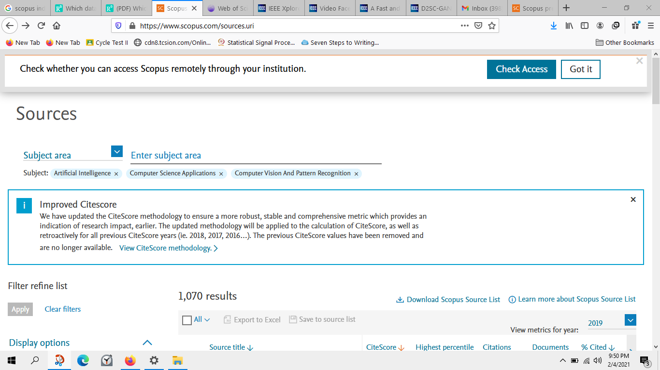

<https://www.scopus.com/sourceid/24254>

This is the location of the first journal that I got from the search

list of websites that i found in the above mentioned journal

1) <https://ieeexplore.ieee.org/xpl/topAccessedArticles.jsp?punumber=8423754>

2) <https://ieeexplore.ieee.org/document/8883245>

3) <https://ieeexplore.ieee.org/document/8680708>

4) <https://ieeexplore.ieee.org/document/9050650>